The Development of Domestic Bond Markets: Interpreting the Mexican Experience

Milan Patel

ABSTRACT
This paper deploys a risk-based approach to analyse the development of the government bond market in Mexico. This paper determines that the development of a market for local-currency government bonds has allowed the Mexican government to significantly enhance its debt profile by reducing and rebalancing the risk factors that contributed to previous crises, containing the possibility of future crises and slashing its debt costs. While this process of bond market development requires the government to develop the institutions that support the market, other factors such as the size of the economy and global market conditions also shape the process.

Contents

1 INTRODUCTION 4
2 REVEALING RISK THROUGH THE CRISIS NARRATIVE 6
2.1 Falling down: the crisis of 1982 7
2.2 Failing to resolve risk: one crisis leads to another 10
3 ASSESSING THE LITERATURE ON BOND MARKETS 12
3.1 Sketching the ideal: why bond markets? 12
3.2 Towards the ideal: determinants of bond market development 15
3.2.1 Initial Policy determinants 15
3.2.2 Institutional Approaches 16
3.2.3 The importance of size and scale 19
4 THE RISE OF MEXICO’S BOND MARKET 21
4.1 The state of the government bond market 21
4.2 Explaining Mexico’s government market development 26
4.2.1 Institutional reforms 26
4.3 The relevance of size 37
4.4 Globalised factors 38
4.5 Introducing new risks? 39
5 CONCLUSION 40
Bibliography 42

INTRODUCTION
In the time after currency crises, debt defaults, and celebrity-backed “drop the debt” campaigns, it can be expected that much of the development literature would highlight the perils of financial imbalances resulting from the habit of excessive borrowing by developing countries. But history does not end at crisis; the hard-learned lessons of the crises drove many developing countries to cultivate domestic financial infrastructure as a way to both manage the risks of future crises and channel domestic resources in a growth-maximising manner. The development of local bond markets often sits at the heart of this reform process, but its relevance is outweighed by a far larger body of literature on external debt. In fact, enhancing our understanding of the role of external debt in the development process requires examining its domestic counterpart, as the driving factor behind governments issuing external debt is typically their inability to borrow domestically at comparatively advantageous terms.
Having suffered two major financial crises directly and endured the indirect consequences of others in the past 30 years, the Mexican government punctuated the remarkable turnaround of its financial fortunes in October 2006 with the issue of a 30-year fixed-rate peso-denominated bond, effectively completing the peso yield curve and signalling investor confidence in the country’s long-term macroeconomic stability. With an active government bond market and a growing market for corporate bonds, Mexico stands out from other Latin American countries that have generally exhibited mixed track records of bond market development.
Mexico’s extensive experience and relative success in domestic government bond market development makes for an ideal case study; hence this paper interrogates the case of Mexico with two main queries. First, how important or desirable has the cultivation of domestic government bond markets been in the case of Mexico? Second, what are the processes that shaped and continue to shape its domestic bond market? The analytical lens that this paper employs emerges from the work of Dattatreya and Fabozzi (2000), which expounds the risks of market involvement of both investors and borrowers. Theoretically, if some of the risks associated with holding local currency debt can be reduced, the government is allowed to redistribute other forms of risk to investors, which allows it to reduce its overall credit risk and shape government bonds as a stable yet high-yielding investment. The relative novelty of the risk-based approach to analysing the development of bond markets seems to reflect a disconnect in the literature: Fabozzi’s work is used extensively in the financial sector and heavily reflects an investor’s perspective, but his work is surprisingly unreferenced in the bond / financial market development literature. Hence, by employing a component of his work—albeit a superficial one--this paper hopes to make a small step in bridging the gap, and possibly enhance the analytical perspectives of both sides in the process.
This paper first intends to show that in the Mexican government has successfully reshaped its risks through the development of the government bond market, diverging sharply from the behaviours that contributed to previous financial crises and slashing the costs at which the government can borrow domestically. The process of bond market development allowed the government to reduce systemic inflation, political, and liquidity risks associated with holding local currency government debt, permitting the issuance of debt that transfers market and reinvestment risks (and currency risk in the case of foreign investors) to investors who demand such securities, thus decreasing the government’s credit risk. Regarding the second aim, this paper finds that while institutional reforms drove the reduction and rebalance of risks that facilitated bond market development in Mexico, they did not represent the only factors in the process: the growth of the economy has likely contributed to the reduction of risks that has facilitated the growth of the market, though to what extent is inconclusive. Further, a confluence of exogenous events in the global financial system also aided the process by reducing the relative costs of participating in the local bond market.
The next section interrogates the history of financial crisis in Mexico, specifically those of 1982 and 1994, using the analytical lens to ascertain the patterns of risks that these episodes exposed and the contribution of debt structure to the crises. The third section analyses the literature on bond market development, first laying out the theoretical case for domestic bond market development and how it could alleviate the risks revealed in the first section, then assessing the impediments to bond market development. The fifth section comes full circle by returning to the empirical case of Mexico in the present day, to assess the process by which the country has progressed bond market development by overcoming the risks outlined in the first section. We conclude by summarising and qualifying our findings, and proposing further areas of research.

REVEALING RISK THROUGH THE CRISIS NARRATIVE
This section offers a brief examination of recent financial crises that have affected Mexico directly, the 1982 Latin American debt crisis and the 1994 “Tequila” crisis, with the aim of deploying our analytical lens to understand the risk factors leading to the crises, and how the borrowing patterns of government fed these risks.

Falling down: the crisis of 1982
Foreign currency borrowing by developing countries from international banks or markets was once deemed to be critical to the development efforts of countries, as such borrowing would inject financial resources into the developing world and compensate for its low savings rates. Domestic currency borrowing by governments can “crowd out” borrowing by other economic actors in the short term, as local interest rates rise in response to increased demand for local currency resources. Foreign currency borrowing does not present such effects in the short term, but implies repayments into the future, acting as a deflationary drag on the economy over time (Turner 2003, 8). Furthermore, as foreign currency debt is typically denominated in currencies that have exhibited a much longer record of stability than currencies of developing countries, such as the U.S. dollar or the euro, it is typically offered at more attractive terms than domestic currency debt, with lower rates of interest and longer maturities. Thus, heavy international borrowing stemmed from the relatively low cost of international funds and the relatively high risk of borrowing domestically in the local currency, which incorporated inflation risk that quickly eroded the value of the cash flows emerging from local currency investments, and liquidity risk, or the risk that low market activity levels would force an investor to sell an investment at a value much lower than that of a recent transaction of the same security (Dattatreya and Fabozzi 2000, 24-25). Liquidity risk can emerge because the lack of local market development limits trading activity, or because of the lack of international interest in exotic currency instruments.
These borrowing patterns by Latin American countries (including Mexico) during the 1970s tremendously increased the levels of foreign currency debt on their books and set the stage for a debt crisis in the region during the early 1980s, after which the rapid change of terms of borrowing made such high debt levels unsustainable. The occurrence of the crisis laid bare the reality that the aforementioned risks now seem far outweighed by the various risks that the crises exposed within the pattern of borrowing.
The most obvious risk is credit (default) risk, or the risk that the borrower becomes unable to make timely payments on the investment to the creditor; like any risk, perception of increased credit risk can shift the value of the investment more than the actual likelihood of default (Dattatreya and Fabozzi 2000, 24). Shadlen (2006) describes four events whose confluence triggered the crisis, which can be tied to other risk factors that fed the credit risk of Latin American countries. First, the rise of the LIBOR rate that determined the interest rate on the floating debt hugely increased debt servicing costs, indicating that borrowing countries bore unmanageable levels of market (interest-rate) risk, or the risk that an investment’s value will change due to a possible future change in interest rates over the course of its life (Dattatreya and Fabozzi 2000, 22). Debt that carries fixed interest rates eliminates this risk for the borrower by transferring it to the creditor, who is typically unwilling to shoulder such risk over an extended future time horizon for a borrower with uncertain credit prospects. The implied trade-off for borrowers is that floating-rate borrowing would allow them to extend the maturity of debt to the maximum possible extent with the aim of reducing reinvestment risk, or the risk that the future interest rate at which the government would need to borrow to pay off previous borrowing—or “roll over” the debt--would rise to unaffordable levels (Dattatreya and Fabozzi 2000, 22). Though the fact that much of Latin America’s debt at the time was characterised as long-term (with terms up to ten years) indicated that reinvestment risk had been partially mitigated, the proportion of Mexico’s short-term debt quickly rose from 7.4% in 1978 to 29.9% of total debt in 1982 (Corbridge 1993, 36-37). Another contributing factor to the crisis was the inability of developing countries to borrow new funds to pay off loans coming due (Shadlen 2003, 3), indicating that developing countries could not fully alleviate reinvestment risk to overcome the rise in interest rates.
Finally, the overvalued exchange rate regimes in place in Latin America both masked and exacerbated considerable currency risk, or the risk that arises when the relative price of the local currency changes (Dattatreya and Fabozzi 2000, 27). The fixed currency overvaluation masked the underlying economic weaknesses of the economy that undermined the ability of borrowers to repay the debt, by creating a mismatch between governments’ dollar-denominated loan liabilities and local currency-denominated assets (Eichengreen, Hausmann, Panizza 2003, 13); this situation is further exacerbated by the fact that the government’s primary income stream, tax revenue, is also denominated in local currency (Turner 2003, 8). Shadlen’s third event is a drop of dollar income through the fall of commodity prices, squeezing the value of Latin American exports and severely denting the dollar-denominated income streams that countries needed to service external debts (Shadlen 2003, 3).
The fourth event, a flight of capital from Latin America toward investments in financial and real estate assets abroad that drained the country’s foreign reserves, was encouraged by the relatively cheap valuation of foreign assets enabled by the overvalued exchange rate and, in cases such as Mexico, a relatively open capital account (ibid., 3). The sum result of these two factors undermined the ability to repay debts denominated in foreign currencies, as maintaining the overvalued exchange rate caused a depletion of dollar reserves that could service debt. The inevitable subsequent devaluation of the local currency strongly magnifies the relative cost of external debt, further eroding the ability of borrowers to repay their loans.

Failing to resolve risk: one crisis leads to another
Faced with all of the above factors, Mexico was the first of the indebted Latin American countries to default on its debt in August 1982. Economic stagnation and high levels of inflation dominated subsequent years, and the effective severance of foreign lending forced the government to seek domestic sources of credit. Seeking to avoid further stoking inflation levels through monetary expansion, governments raised the sale of local-currency treasury bills called CETES to the banking system (Buffie 1989, 160). Here is where the story of the domestic bond market in Mexico originates: CETES were first issued in 1978, but lack of quantity inhibited liquidity in the secondary market, further constrained by government-controlled interest rates (Sidaoui 2002, 151). By 1985, large issuance of these securities to banks (reflecting stubbornly high deficit levels) effectively crowded out lending to the private sector: the yield on 3-month CETES in December 1985 reached 74.1%, exceeding the average cost of bank funds at 65.7% (Buffie 1989, 160-161).
By the time of the next major financial crisis in 1994, the composition of domestic government debt had diversified to include issuance of CETES to terms of up to 1 year, floating-rate securities known as Bondes, and short-term dollar-linked bonds called Tesobonos. Calvo and Mendoza (1996) describe the instrumental role of these securities in the 1994 crisis, explaining that in the context of massive credit expansion and fixed exchange rates during the years before the crisis, foreign investors directed huge amounts of volatile capital towards these securities, particularly CETES. The assassination of a presidential candidate shocked investor confidence and sparked a sell-off of CETES that severely dented foreign reserves, which reveals the heightened perception of political risk, or the risk of a political action affecting the value of the investment (Dattatreya and Fabozzi 2000, 27). Dattatreya and Fabozzi use the definition of political risk to point to specific political decisions that affect valuation, such as the introduction of a withholding tax on the security. No specific political action was threatened in this event, but the possibility of such actions emerging from an uncertain presidential succession shook investor confidence.
Believing that reducing the currency risk of its debt for investors would restore confidence, the government attempted to restore confidence in the market by raising its own currency risk, increasing the share of Tesobonos on the government debt market rose from 4 to 75% between the ends of 2003 and 2004 (Calvo and Mendoza 1996, 244). But the haemorrhage of reserves continued, and the diminishing attractiveness of Tesobonos left the government unable to roll over its debt. The embryonic debt market that emerged in the wake of the previous debt crisis allowed the Mexican government to finance its debt domestically, but had not yet developed to a level that allowed the country to reduce its currency and reinvestment risk, which was particularly heightened due the existence of the fixed exchange rate regime and high exposure to volatile foreign capital flows. The crisis confirmed to the Mexican government that management of the public debt needed to extend beyond fiscal reforms to address the weaknesses of its debt profile that left the country vulnerable to the volatility of foreign investment (Jeanneau and Verdia 2005, 96).

ASSESSING THE LITERATURE ON BOND MARKETS
This section assesses the literature on developing the market for local currency government bonds. Section 3.1 outlines the case for developing market with the aim of understanding how bond markets can alleviate the risk factors described in section 2. Then section 3.2 assesses the determinants of market development to identify the factors that inhibit its development and pursuit of the alternative option, borrowing abroad.

Sketching the ideal: why bond markets?
The development of domestic bond markets benefits the economy by providing a wide-ranging set of financing options to domestic borrowers in an efficient manner, and correspondingly providing lenders with a wide range of investment options; critically, borrowing and lending activity within a well-developed market should mitigate risks to levels that do not portend future systemic crises. Developing the local bond market facilitates borrowing in local currency at terms that are comparably attractive to those available via international markets, without exposing the issuer to potentially destabilising currency risk. A well-developed bond market also facilitates the possibility of government borrowing at fixed rates across the maturity spectrum, allowing the government to pass reasonable levels of both market and reinvestment risk to private sector investors without facing an extreme trade-off between the two.
This ideal of funding deficits via the markets contrasts starkly with the previous patterns of domestic borrowing, which involved repression of the financial system that contributed to macroeconomic instability. Before the wave of liberalizing financial markets that began in the 1980s, governments often forced banks to finance the public deficit by lending at below-market rates, typically by instituting high reserve requirements that forced banks to hold government debt, or mandating ceilings on interest rates in order to direct credit towards favoured sectors or parties (Fry 1997, 69). Monetisation of the deficit by borrowing from the central bank, which leads to a rise of inflation, represented another prevalent method of deficit financing otherwise known as the “inflation tax” (Fry 1997, 3-5). By issuing local currency bonds via a competitive process, governments borrow at market-determined rates without resorting to financial market repression that increases inflation risk for the whole market. Competitive determination of interest rates to accurately reflect the cost of funds is one of the most important reasons to develop a bond market (Jeanneau and Tovar 2008b, 47).
Local bond market development presents further potential for reducing inflation risk by improving the conduct of monetary policy. As governments retreat from financing deficits through market repression and monetisation and turn to the market for borrowing, central banks will typically use government securities to implement monetary policy; thus a well-functioning money market assures the smooth transmission of monetary policy to the market (Turner 2003, 5).
Furthermore, the development of a domestic government bond market is imperative for the development of a domestic corporate bond market, which expands the financing options for corporations. Beyond the mitigation of risk for governments themselves, the creation of a government bond market has almost always been a precondition of the development of a corporate bond market. One reason is alluded to above: government borrowing on the bond markets, rather than reverting to repression of the financial sector to fund deficits, means that more financial resources should be available to firms. Another reason relates to the informational function of government bond markets: a liquid government bond market generates trading activity on government bonds that produces “risk-free” yields across a wide maturity spectrum within a particular country, forming a yield curve used to price corporate debt (IMF 2005, 104). A third reason is that the costly institutional and technical infrastructure required to operate a government bond market, as well as the experience gained in running the market, ease the way towards operating a corporate bond market (World Bank 2001, 374). Finally, corporations bear many of the same borrowing risks as governments such as currency risk from mismatches (IMF 2005, 104), implying that the steps taken to broaden the domestic financing options for governments would open the same risk-reducing possibilities for firms.
Systemic improvements to the terms received by borrowers should have concurrent positive effects for investors by reducing credit risk. The whole domestic investment environment improves if borrowers can better manage their risks by borrowing on terms that reduce balance sheet mismatches, and increase the likelihood that they will repay the investor in full. The end of financial repression further means that domestic investors’ money is not being channelled towards the government at disadvantageous terms; investors face returns determined by the market that fairly reflect the risk that they face, and the outflow of wealth from the developing country that searches for fair returns in other markets of the world should fall. For the same reason, foreign investors in search of high yet fair returns are more likely to invest in the developing country. The availability of longer-term securities encourages foreign investment towards more stable and durable investments that tend to have longer-lasting positive economic effects, and mitigates the destabilising tendencies of volatile capital flows. Creation of the bond market should reshape the relationship between borrowers and investors in positive ways that allow the participation of foreign investors in the economy without introducing unsustainable levels of foreign currency debt.

Towards the ideal: determinants of bond market development
Eichengreen and Hausmann (1999) term the reliance of developing countries on foreign currency debt resulting from their inability to use the domestic currency to borrow abroad as “original sin.” This section expounds the determinants behind the domestic version of this original sin, the inability to borrow from local bond markets at reasonable terms.

Redirecting policy
Stabilising the value of the currency by implementing a sensible monetary policy to combat inflation generally represents the first step towards establishing the credibility of local currency government paper. Burger and Warnock (2004) determine that stable historical inflation rates contribute to the development of local bond markets and reduced dependence on foreign currency debt by attracting investors to the local currency. These results echo those of Jeanne (2005), who states that a lack of monetary credibility leads to the dollarization of debt in the developing world. The idea of credibility implies that the government must maintain inflation at low levels for an extended period in order to convince investors of its sustained commitment to low inflation well into the future. Cowan and Do (2003) point out a potential “dollarization trap,” in which excess dollarization of debt that results from original sin itself hinders the ability of the government to build credibility, as it cannot demonstrate anti-inflation behaviour if its liabilities were denominated in local currency and the temptation to monetising debt was at its highest.
Claessens et al. (2003) expound on a related viewpoint, stating that exchange rate policy affects the currency denomination of bonds, as the implied guarantee that governments will expend international reserves to defend the valuation induces firms to borrow in foreign currency, while governments will tend to borrow more in foreign currency to demonstrate commitment to the exchange rate regime. Thus, a free floating or managed exchange rate regime that removes the moral hazard arising from the implied guarantee should have the effect of increasing borrowing in local currency and reducing currency risk. Assessing against Cowan and Do’s point, a trade-off seems to exist between the government demonstrating its commitment to monetary stability through issuance of local currency debt and commitment to the fixed currency regime through the issuance of dollarized debt.

Institutional approaches
However, the distance is vast between a one-time policy change that reduces inflation, and a permanent reduction in inflation risk (real or perceived), suggesting that permanently cementing an anti-inflation stance as part of the “rules of the game” require institutional changes. Reinhart et al. (2003) outline the argument of debt intolerance, which describes the inability of developing countries to handle external debt at levels than is otherwise indicated by the quality of their credit rating when compared to borrowers in the developed world that carry similar ratings, as evidenced by a history of relatively numerous crisis and defaults. Their work theorises that a history of default creates institutional weaknesses within a country that greatly increases credit risk; thus, in order to avert subsequent default, institutions must be strengthened to fortify the country’s ability to digest larger debt burdens. While their concept is initially applied to external debt, they state that domestic debt intolerance shares the common cause of institutional weakness, which contribute to dollarization and weak maturity structures of debt that enhances vulnerability to crisis (Reinhart et al. 2003, 50). Reinhart and Rogoff (2008) extends this work by theorising that inclusion of domestic debt in the analysis of sovereign default episodes helps to explain why so many countries default on their external debts at relatively low levels. For example, Mexico’s debt level of 48% of GDP in 1982 (Panizza et al. 2006), itself well below the 60% Maastricht treaty threshold considered safe enough to enter the Euro zone, was comprised of only 2/3 external debt (ibid.). The paper also points out that domestic debt tends to increase in the build-up to debt crises concurrently with increases in external debt (Reinhart and Rogoff 2008, 15); the increase of inflation resulting from the monetisation of domestic debt would exacerbate the problem of capital flight mentioned above as a contributing factor to the 1982 crisis.
In sum, debt intolerance arises from the inability of developing countries to issue domestic debt that mitigates their risk to manageable levels, which traces its roots back to institutional weaknesses. It follows from the debt intolerance literature that the weakness of the domestic debt market, which forces borrowers towards debt characterised by high and underestimated levels of currency, reinvestment, and market risk, arises from institutional weaknesses.
What are the institutions that most affect bond market development? Burger and Warnock (2004) find that countries with strong legal systems have more developed local bond markets; in particular, the rule of law broadens local bond markets, while stronger creditor rights (as enacted into law) facilitates reduced dependence on foreign currency bonds (Burger and Warnock 2004, 8) by encouraging the participation of foreign investors in the market. The rule of law is particularly critical, as strong and efficient courts and clearly defined property rights are needed to support the negotiation of bonds as contractual arrangements (de la Torre and Schmukler 2006, 89).
The literature on the determinants of institutions branches off in two directions (Girma and Shortland 2007, 1). One branch takes a “deep institutional” perspective on financial development focusing on predetermined and mostly unchangeable institutional characteristics that shape the legal structures and property rights that underpin financial markets--specifically the relative inability of civil law systems (such as Mexico) to evolve advanced financial markets when compared to common law countries. Acemoglu et al. (2001) fall within this group, stating that settler mortality in European colonies directly affected institutional depth in the colony, which creates “path dependence” in the evolution of future institutions. Another set of literature takes a “political economy” approach to the institutional question. Rajan and Zingales (2003) theorise that financial underdevelopment emerging from financial repression stems from a lack of political goodwill for developing the infrastructure of the market. Incumbent economic actors with established positions in a constrained economy benefit from the privileged access to finance implied by financial repression, and tend to oppose creation of a market for finance that would open access to new competitive players in the economy. Haber (2005) extends this line of thinking to the Mexican context, explaining that the institutions that govern the financial system are inherently linked to institutions that limit the authority and discretion of the government, hence depend on the overarching process of political reform and democratisation. The government designs the institutions that support the market and structure prudent behaviour in the banking system, but it is not a disinterested party in the process. As the biggest single borrower in the country, the government is probably the incumbent that benefits the most from financial repression and has the incentives to control finance as a means to distribute favours to its business supporters or underline electoral support among key constituents for the ruling party, as the ruling PRI did beginning in the 1960s when it increased social spending for industrial workers and other powerful supporter groups before elections (Haber 2005, 17). The shaky institutional structure that emerges under this arrangement, with weak property rights at its core, fuels expropriation risk as a component of political risk, not by its typical mode of asset seizure, but through borrowing below market rates, onerous reserve requirements, or expansion of the money supply. Banks are incentivised to operate in this environment of heightened expropriation risk with lucrative privileges and restrictions on new entrants to the system (Haber 2005, 11).

The importance of size and scale
The work of Eichengreen et al. (2005), while acknowledging the importance of institutions, presents a fundamental challenge to the above explanations of original sin. The authors question the relevance of a government’s anti-inflation credibility, as issuance of inflation-indexed debt would create bonds free of inflation risk; nor does the regression on the determinants of original sin attribute significance to monetary stability (Eichengreen et al. 2005, 236). More boldly, they contradict much of the prevailing institutional literature by arguing that their regressions show no statistically significant correlation between institutional quality and original sin, using multiple measures of institutional quality such as the rule of law drawn from Kaufmann et al. (1999) and Acemoglu et al (2001) data on settler mortality (Eichengreen et al. 2005, 241). Instead, they find country size (measured using total GDP, total domestic credit, and total trade) to be the only robust determinant of original sin (ibid., 250), suggesting that concentration of international debt issuance in a few currencies cannot be shifted by reforms within the developing country (ibid., 252). Given the transaction costs associated in dealing in multiple currencies, the benefits of diversifying currencies in a portfolio fall faster than the costs. Further, as the opportunities for diverse investment are much more numerous in larger countries than in smaller ones, the world will tend to invest in the currencies of a few large countries (Eichengreen et al. 2005, 249). In other words, network externalities affect demand for currencies, since the value of using a currency internationally can depend on the number of traders and investors who also use it (de la Torre and Schmukler 2007, 95). For a foreign investor, exposure to an exotic currency brings a package of inflation, currency, liquidity, and even political risk that may far outweigh the potential investment opportunities in the currency.
The relevance of market size also points to the role of economies of scale in market development: quantity of issuance drives the liquidity of a security and will tend to be bigger in larger economies, while it is difficult to share the substantial fixed costs of developing the technical infrastructure to operate the domestic market if the market is very small (IADB 2006, 141). These results imply that smaller economies may actually find it more effective to issue bonds in foreign currency (de la Torre and Schmukler 2007, 96).

THE RISE OF MEXICO’S BOND MARKET

The state of the government bond market
As in other areas of the development field, concepts of bond market “development” and “underdevelopment” are inevitably normative judgements of the status of the market that can be measured along a number of dimensions. Figure 2.1 displays a common measure of the size of the market--market capitalisation as a percentage of GDP.
Assessing the development of the bond market using this measure can be counterintuitive, considering the fact that overly burdensome levels of government debt could destabilise the economy. However, a critical mass of government debt is required to generate the trading activity that produces market rates along the local currency yield curve used to price other issues on the market.
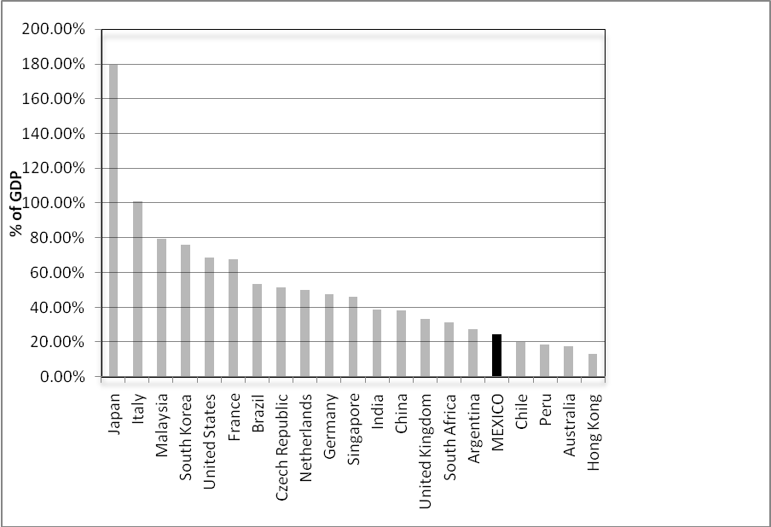
Figure 4.1 Market capitalisation of domestic government bond markets for select countries (% of GDP), December 2007
Source: Calculated from Bank of International Settlements (BIS), IMF data
In terms of its regional peers, Mexico’s relative size exceeds that of Chile at almost the same level of economic development as measured by GDP per capita, but lags behind less-developed Brazil due to that country’s proportionally higher share of government debt to GDP. Globally, its market appears to be slightly smaller than South Africa’s in relative terms, though South Africa’s total GDP is less than half as small as Mexico’s. Perhaps the most striking disparity is the relative size of Mexico’s market to South Korea’s, whose market capitalisation of 76% of GDP far outstrips Mexico’s at 24%.

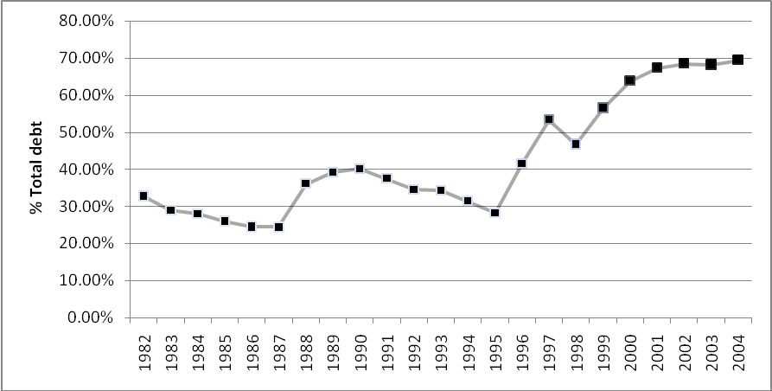
Figure 4.2 Ratios of domestic public debt to total public debt
Source: CLYPS database

Figure 4.2 considers the relative size of the domestic government debt market. The government has largely contained its exposure to foreign currency debt: the proportion of local currency debt within total debt has risen from more than 30% in 1982 to around 70% in 2004, with the downward swing leading up to the 1994 crisis reflecting the government’s swap of local currency debt to dollar-linked Tesobonos. Total debt levels have been constrained below 40% of GDP, well below the high of near 80% in the aftermath of the 1982 crisis (IMF), meaning that the government has not simply increased the share of domestic debt simply by adding on to the debt pile. At the same time, increasing holdings of local currency debt has not necessarily implied a trade-off between currency and reinvestment risk: the average maturity of outstanding domestic government debt has increased from 0.8 years in 1995 to 5.9 years in 2007, which is even higher than the 2007 average of 5.1 years for a sample of industrial countries (BIS 2008).
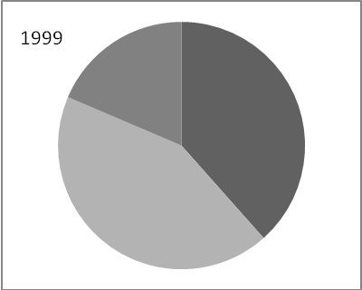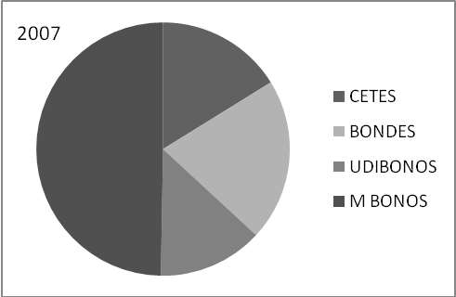
Figure 4.3 and 4.4 Composition of domestic government debt, 1999 vs. 2007
Source: Banco de México

The government has managed to extend the average maturity of its debt by changing the composition of its debt. Figures 4.3 and 4.4 demonstrate that the composition of government debt has shifted from the predominance of CETES, Bondes (floating-rate bonds), and Udibonos (inflation-linked bonds) in 1999 to a situation where M Bonos, or long-term fixed-rate bonds analogous to treasury bonds in other countries, dominates the government debt portfolio. The issuance of M Bonos to terms of 30 years provides convincing evidence that the Mexican government has managed to overcome domestic original sin, or the inability to issue local currency debt for long-term periods.
In terms of liquidity as a measure of market activity, most measures indicate relatively high levels of trading activity. Turnover on the government market has consistently stayed above 800%. By another measure, the bid-ask spread on the most liquid government instrument, the 10-year M Bono, narrowed to 5 basis points by 2005 (Castellanos and Martínez 2008, 63), further indicating high levels of liquidity.
By multiple measures, Mexico’s credit risk has declined markedly since its last crisis. The most well-known measure is its Standard and Poor’s rating: its foreign currency rating has risen from BB in February 1995, crossing the investment-grade threshold to reach BBB- in February 2002, and sits at BBB+ as of August 2008 (Standard and Poor’s 2007, 2008).
Another indicator of risk is the government’s cost of domestic borrowing, as illustrated by its yield curve. Figure 4.5 shows the evolution of the yield curve since 1997, during the months when the government added new instruments to the yield curve. In 1997, issuance was confined to CETES of up to 1 year at yields above 25%; each subsequent expansion of the yield curve shows a drop in government borrowing costs until about 2003, after which rates stabilised. The first auction of the 30-year bond in October 2006 at a yield of 8.08% could not have been fathomed even 9 years before.
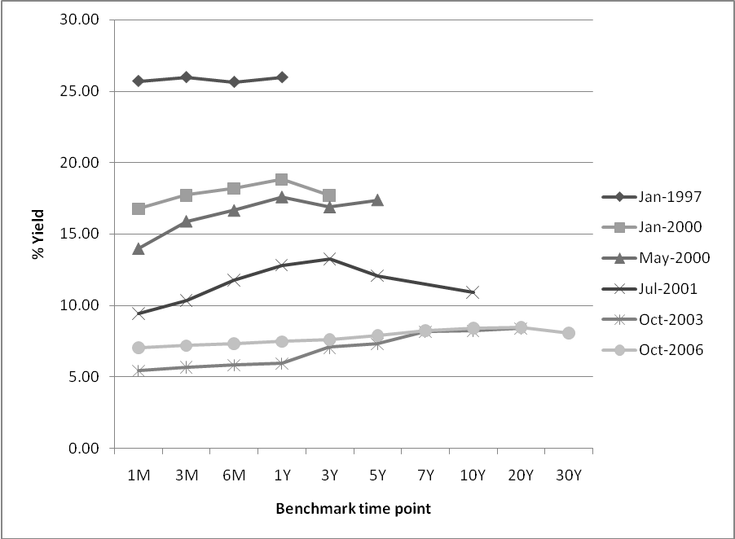
Figure 4.5 Mexican peso government yield curve since 1997, measured by yield rates at auction. M = months, Y = Years
Source: Banco de Mexico

Finally, the Mexican government reckons that its debt management capabilities have directly affected its fiscal position by reducing foreign debt exposure or actively swapping older expensive foreign-currency debt for new debt at better terms, leading to costs savings of approximately USD 35 billion (Arai 2006).

Explaining Mexico’s government market development

Institutional reforms
The World Bank states that the development of the government bond market can be imagined as an exercise in building credibility in which governments must signal a consistent commitment to a market-oriented funding strategy, implying that governments should adhere to market principles of broad access and transparency, commit to market financing, and develop the regulatory framework to support market development (World Bank 2001, 11). As indicated in section 3.2, credibility-building begins with macroeconomic stability to tame high levels of inflation that undermine the value of the local currency and increase uncertainty associated with holding local currency paper (Turner 2003, 5). Furthermore, the process of taming inflation signals the institutional commitment to shift government deficit financing behaviour in a market-oriented direction, by not resorting to financial repression or the inflation tax. In Mexico, the process began with the commitment of the central bank to conduct monetary policy through open market operations, moving away from forced loans to governments, centrally-determined interest rates, and high reserve requirements that characterised repression of banks (ibid., 5). Interest rates were liberalised in 1987, and bank reserve requirements were converted to a liquidity coefficient (requirement to maintain a percentage of assets in liquid securities) in 1989 which was subsequently removed in 1991 (Sidaoui 2002, 7).
Institutional changes sustain this credibility over time beyond these policy changes in ways that erode risk premiums, which is particularly important in a context where the government is increasing issuance of government debt in local currency that could increase inflation risk. Granting the central bank independence in determining monetary policy is a critical institutional reform that signals a commitment to low levels of inflation, by separating the rate-setting institutions from the government bodies whose interest lies in borrowing as cheaply as possible, and who may be tempted to again resort to the inflation tax. Having insulated inflation policy from the political decision-making process, the central bank can also safely work with the country’s finance ministry to play an active role in bond market development. Market issuance of government debt changes the old transmission mechanisms of monetary policy, and the central bank will want to work with the government to determine which instruments are ideally suited to conduct open market operations; without coordination, the central bank would be free to issue and buy its own securities without consideration of the effects on the development of the government bond market. With these institutional measures in place, inflation risk can be contained to a reasonable level.
Once policy and institutional reforms restore the investment value of the currency, further institutional reforms are required to expand the market investor base and diversify sources of demand for government debt beyond the banking system (Hanson 2007, 2). Expanding demand for the types of bond products that governments wish to sell, like fixed-rate and long-term securities, will pass market and reinvestment risk to investors who demand such products. Mexico’s experience points to institutional investor reform as the most important set of demand-side reforms, as institutional investors tend to hold high shares of outstanding government debt in developing countries (IADB 2006, 151). The privatisation of government pensions in 1997 from a pay-as-you-go system to individually capitalised accounts is considered a key step towards the development of the market (Castellanos and Martinez 2008, 56). Pension funds (called SIEFOREs) represent a significantly large pool of savings within the country, growing from 1% of GDP in 1998 to 6% in 2005, and holding 82% of outstanding government debt by the end of 2005 (ibid.) The high holdings in government bonds stems from regulations governing these funds that mandate that at least 65% of fund assets should be held in government bonds (ibid., 57) as the securities with minimum risk within the country, as well as the fact that during the transition to individually-funded accounts, governments must still make payments to the currently retired population (Borensztein et al. 2008, 11). Such restrictions may resemble aspects of financial repression prevalent in previous years as pension funds effectively serve as “captive investors” in government debt (IADB 2006, 151), and from a risk-management perspective it is not advisable to expose the whole fund to the risks of one issuer--especially if that issuer has been prone to default in previous years. However, pension holdings in government debt have generally exceeded minimum levels, and have not shifted significantly even after rule changes in 2002-03 expanded the number of eligible issues and introduced limits for credit rating (Castellanos and Martinez 2008, 57).
Pension funds make ideal buyers of government debt, because the extended timeframe of their individual accounts and the defined nature of the benefits paid out mean that their demands tend towards securities with longer terms and fixed rates—precisely the types of debt that governments prefer to issue in order to ensure certain funding at fixed rates over long periods of time (World Bank 2001, 99). Like investors demonstrating similar preferences such as life insurance companies, pension funds are theorised to play a crucial role in generating demand for long-dated debt, thus underpinning market development by supporting the long end of the yield curve (Turner 2003, 16). Hence their existence allows the government to transfer market and reinvestment risk to a set of investors best geared to handle such risks. Detracting from the contribution of pension funds to market development is their inclination to buy and hold securities in line with their long-term investment horizon, limiting their contribution to the liquidity of the market (Borensztein et al. 2008, 11).
Mutual funds are another potentially strong source of demand in developing markets, especially providing a crucial linkage for small-scale investors to pool resources into the bond markets (Turner 2003, 7); they are also not as motivated to employ the buy-and-hold strategy of pension funds, so active trading on the part of mutual funds could significantly develop market trading activity and counter liquidity risk. Restrictions on the activities of mutual funds have hindered their development in Mexico; government restrictions on short-term investments, meant to encourage investment in long-term holdings, have impeded the ability of mutual funds to compete with banks for depositors, because such investors prefer to keep their money in short-maturity investments when faced with expected market risk (Sidaoui 2002, 160). Changes to rules have allowed for diversification of collective instrument vehicles to cater to diverse risk appetites (Sidaoui 2002, 161).
Figure 4.6 shows that these reforms have facilitated diversification away from bank holding of government debt. Pension funds have come to occupy a consistently large block of the market, while mutual fund and foreign investor participation has grown markedly since 2005, holding 15.3% and 13.7% of the outstanding government debt stock respectively as of August 2008. .
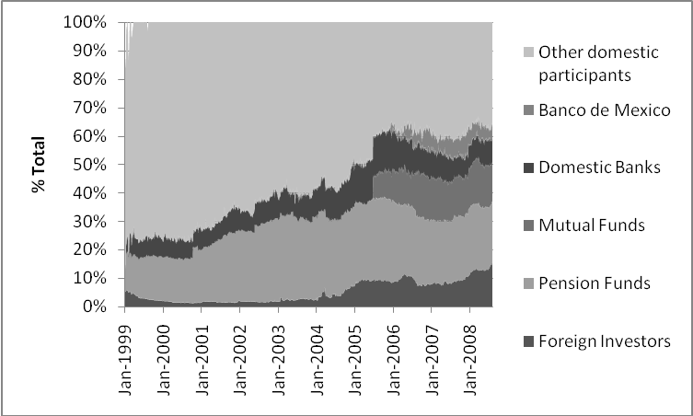
Figure 4.6 Domestic government bonds by holder
Source: Banco de México

The institutional reforms specific to foreign investor participation in the bond market began in 1990 with the lifting of restrictions on portfolio investment by non-residents in fixed income securities, coinciding with the opening of the country’s capital account (G-20 2003, 4). Perhaps even more critical was the decision to continue the liberalisation and market development process after the 1994 crisis, in recognition of the fact that the process of building institutions around the liberalised market had already proceeded too far to reverse the liberalisation already achieved(G-20 2003, 8). While the value of foreign investor participation has been questioned due to its role in the 1994 crisis, a key reason behind the logic of domestic market development is to harness the benefits of globalisation by strengthening the links between domestic and international markets. The availability of longer-term debt in a well-developed bond market diversifies investor choice away from the short-term debt that contributed to the volatility preceding the 1994 crisis: foreign investors currently buy above 80% of new M Bono issues (Castellanos and Martínez 2008, 60). Participation of foreign investors can increases liquidity (Turner 2003, 16), and also bring international trading and risk management expertise to the local market.
Other institutional changes that have particularly encouraged the participation of foreign investors in Mexico are the development of exchange-rate and derivatives markets. Exchange-rate markets that trade currency futures and options allow investors to hedge their positions on the Mexican peso, and the highly liquid nature of such contracts (pesos are the second-most traded emerging market currency after the Korean won) increase the attractiveness of holding peso assets (Castellanos and Martínez 2008, 57), especially for foreign investors who must manage currency risk on top of the other risk factors associated with holding Mexican government debt. The effects of derivatives markets are more complicated because the underdevelopment of underlying securities markets causes the underdevelopment of associated derivatives contracts. However, these markets assist investors to hedge their interest rate positions; significant activity in interest rate swaps on the over-the-counter (OTC) market complements activity on the fixed income market. Trading in the 28-day TIIE contract (an interbank rate analogous to LIBOR in setting interest rates for floating debt) has come to account for almost 100% of trading in fixed-income contracts on Mexico’s derivatives exchange MexDer, which has operated since 1998 (MexDer); while this points to relative lack of activity in bond future contracts, trading on short-term rates has supported the longer segment of the yield curve by facilitating hedging and pricing of longer-term interest rate swap contracts (Jeanneau and Verdia 2005, 95).
At the centre of supply-side institutional development for the government debt market is a clear public debt management strategy that prioritises improving the government debt profile. Since the early 2000s, Mexico has followed such a strategy consisting of 5 elements: shifting to domestic financing of fiscal deficits; lengthening the maturity structure of government debt; developing a liquid yield curve; enhancing predictability and transparency of debt issuance; and introducing initiatives to strengthen the government debt market (Jeanneau and Verdia 2005, 98). The statement of this strategy, backed by subsequent actions that demonstrate the government’s commitment to its implementation, reaffirms the government’s desire to build its credibility amongst market participants. However, the tangible effort of building the market lies in the gradual measures that fortify the predictability of the debt issuance process and shape participants’ perceptions of the “rules of the game” that comprise the debt market institution. Ending financial repression and reforming macroeconomic institutions are such measures. Reducing dependence on foreign borrowing is another measure that is particularly demonstrative of the government’s commitment to the local market, as the government must not only accept the market’s price for purchasing its debt even if it considers the price “too high” (IADB 2006, 244), but also must pay a substantial premium over the cost of similar foreign currency debt just to issue the debt domestically or borrow at other terms that it would otherwise consider disadvantageous (such as short maturities, floating rates, or indexation to inflation). The trade-off for this extra cost, however, is the growth of confidence among investors that the government is committed to the market borrowing strategy for the long term (World Bank 2001, 12). As the credibility of the government grows over time, the government will be able to increasingly issue debt at favourable terms.
The spark of reorientation towards the market in the local currency can be found with the initial issuance of CETES in the late ‘70s and the aftermath of the 1982 crisis, when secondary market trading began to emerge after banks and brokerages were permitted to submit bids at public auction for CETES, and Banco de Mexico shifted towards conducting monetary policy with marketable government securities (Sidaoui 2002, 151). These measures facilitated the growth of an active money market which would eventually lead to market-determined interest rates (G-20 2003, 2). While macroeconomic credibility took hold, the government began to address the reinvestment risk of its short-term holdings, first by extending the maturity of CETES out to 1 year, and then by extending the maturity terms of its debt through the introduction of floating debt linked to CETES auction rates (Bondes) in the early 1990s and inflation-linked debt (initially Ajustabonos, which gave way to Udibonos in 1996). Gradual extensions of maturity of these instruments corresponded with investor confidence in the market, and by 1999 a 10-year Udibono was on the market. Less noted in the literature, the extension of coupon periods also seems to correspond with a perceived fall in reinvestment risk as creditors accept longer time periods between interest payments, allowing the government to retire Bondes that reset rates and pay coupon on a monthly basis in favour of bonds with quarterly or semi-annual coupons.
Finally, by 2000 the confidence of investors was at a high enough level for them to accept taking on more reinvestment and market risk, opening the way for the issue of fixed-rate government bonds with a 3-year maturity (M Bonos). Furthermore, the government proved adept of extending out the yield curve after the first issuance, issuing a 20-year fixed rate bond in 2004 and a 30-year bond in 2006, both at a manageable 10% coupon rate (Banco de México).
The government sector also encompasses the debt of other entities associated with the government. Mexico’s central bank, the Banco de México (BdM) has been an invaluable participant in market development by providing expertise through its role as the government’s fiscal agent in conducting weekly bond auctions, while improving its monetary regulation capabilities in coordination with the government. Between 2000 and 2006 the BdM issued monetary regulation bonds (BREMs), a floating-rate note with monthly coupon payment and daily rate reset, to prevent the accumulation of foreign reserves from increasing the monetary base (Castellanos and Martínez 2008, 62-63). In 2006, the BdM coordinated with the central government to switch issuance of BREMs by the BdM to a new type of central government security, Bondes D, which carried the same coupon characteristics. This arrangement allows the BdM to conduct monetary policy operations with an instruments tailored to its specifications, with the added benefit of letting the government issue Bondes D specifically to generate the peso proceeds to buy dollar reserves from the BdM, which in turn is used for early pay down of its multilateral loan and market dollar debt (Banco de Mexico 2007, 86). The government sector also encompasses debt issues of the country’s deposit insurance agency, the Institute for the Protection of Bank Savings (IPAB), whose bonds comprise about 5 ½% of GDP (Banco de Mexico) and carry a government guarantee. The agency auctions floating-rate bonds weekly to finance its deposit insurance operations, as well as the costs incurred from the bailout of banks after the 1994 crisis (Jeanneau and Verdia 2005, 100).
The government has taken a number of steps to minimise liquidity risk within the secondary market in government securities. First, it coordinated with a select number of financial entities to create a primary dealer / market maker system in 2000, in which primary dealers tasked with “making the market” buy all government securities offered at auction and two-way quotations by buying and selling government securities with the rest of the market, in exchange for bidding privileges and special credit lines (IADB 2006, 148). In addition to the desired effects on liquidity, this arrangement should also have informational effects in generating accurate pricing information on government securities, which serves as a benchmark for pricing the corporate bond market. While such an arrangement may encourage collusion between primary dealers in the auction process, the overall significant drop in the cost of funding Mexico’s debt over time indicates that this effect does not have a measurable negative effect. Second, in 2003 and 2004 changes to regulations on the repurchase (repo) market have helped primary dealers and the central bank to generate market activity by lending out their inventoried securities (Jeanneau and Verdia 2005, 98).
Third, in 2005 the government began to allow “stripping” of M Bonos and Udibonos, or separate negotiation of the principal and interest segments of those securities. Such a move creates a market of long-dated zero-coupon instruments beyond CETES, which particularly appeals to institutional investors with long time horizons such as pension funds (Castellanos and Martínez 2008, 63). Finally, the government has strengthened activity in its yield curve by concentrating new issuance on the securities that comprise the yield curve (also called “tapping” existing securities) instead of issuing a series of new bonds for each new issuance and splitting the trading activity for issuances that essentially carry the same reinvestment risk (Jeanneau and Tovar 2008a, 149).
The government’s attempts to solidify certainty in the market transcend formal rule making, and relate to the norms that the government has cultivated in the market. One significant factor in market certainty is the annual publication of the Mexican government’s debt strategy for the upcoming year, supplemented by quarterly updates, which indicates amounts to be issued for each security and any new securities that may emerge during the upcoming year. Abiding by the strategy has required the government to consistently sell the whole amount of debt offered at auction and not reject the offered market price as being too high, even though technically it reserves the right to withdraw the debt from auction. Such has been the consistency of this behaviour that the market no longer questions the government’s commitment to the market price of its debt, and investors now plan their decisions according to the debt strategy.
The existence of these and other associated norms, such as the government commitment to benchmark issuance as described above, comprise key elements in the building of the market institution and point to constraints that have evolved on the discretionary actions that the government can possibly take in the market. The market is now strong enough to counter fiscally irresponsible actions by the government by forcing it to pay higher levels of interest. Coinciding with bond market development, political reforms ended the semi-authoritarian rule of the PRI and introduced further institutional checks, such as real multiparty competition and an autonomous Congress, on the government’s ability to manipulate the financial sector to its own ends. Combined with the autonomy of the BdM, the minute informal rules that shape the behaviour of the bond market and the larger process of democratisation are all institutional changes that contribute to the significant reduction of political risk in the country, most importantly the risk that the government will not effectively expropriate the debt assets of investors as it once did, even through subsequent changes of the Mexican government. These changes seem to support the idea that the institutional determinants of financial market development are shaped through the fpolitical economy of a country as described by Rajan, Zingales, and Haber, transcending the path dependency implied by deep, immutable institutional determinants.

The relevance of size
What effect does size have on bond market development? The difficulty of analysing the relevance of size lies in the fact that no firm threshold statistic exists at which a country automatically develops a debt market. Hence it is nearly impossible to determine conclusively whether the Mexican economy is “large enough” to support the bond market. We can, however, assess if the size of the economy and its interlinkages with the rest of the world have increased in support of market development, and how these changes have shifted the country’s package of risks in favour of the domestic bond market. In terms of relative measures, Mexico’s relative share of the world economy has hovered around 1.5% of global GDP since 1980 (IMF 2008). However, its share of global trade has expanded from about 0.5% of total global GDP in the early 1980s to 1% in 2005 (World Bank World Development Indicators), reflecting Mexico’s heightened liberalisation and globalisation pushed by the numerous free trade agreements it has signed, most notably NAFTA. This expansion of trade would have increased the number of global financial transactions denominated in Mexican pesos, boosting the network externalities of the peso and reducing the liquidity risk of holding the currency.
In absolute terms, its GDP has grown by more than 6 times its 1980 levels, from 205 billion dollars in 1980 to 1.2 trillion in 2007, measured in current prices (IMF), supporting the scale of the domestic bond market and further reducing liquidity risk.

Globalised factors
Domestic bond markets do not operate autonomously of the international market; indeed, part of the rationale behind domestic market development is to create sustainable linkages with the international debt market. Considering these linkages and the desired role of foreign investors in the domestic market, it is logical to assume that international market factors, exogenous to the actions of the government, could potentially have a large effect on market development. Perhaps the international market’s most decisive role in Mexico’s market development was to stop lending to the country after the emergence of the 1994 crisis, which forced the government to develop the channels within the country to finance its deficit. Initially the sudden increase in government debt after the crisis often made some level of inflation financing inevitable, but this behaviour shifted as the government built the market.
Mexico’s success in building its market in recent years could have emerged from the fact that bond market development coincided with a time of low interest rates in the industrial world that drove its investors to “search for yield” in the emerging markets in order to boost returns. This search has had the effect of increasing demand for emerging market paper and lowering the domestic borrowing costs of developing world governments (Jeanneau and Tovar 2006, 52). Additionally, Tovar (2005) points out that higher commodity prices have enhanced the terms of trade of Latin American countries and caused an appreciation in exchange rates, which raises the value of holding local currency paper.

Introducing new risks?
Has debt market development actually increased risks for Mexico? Hansen (2007) is one of the few authors to focus specifically on the increased risks emerging from domestic debt markets. The main risk that he points to is the crowding out of private debt by high levels of government debt, supported by the fact that growth of domestic debt has been larger than growth of bank credit to private sector entities. The burden of this phenomenon is mostly borne by small and medium enterprises and rural borrowers, who are not able to access international or domestic bond markets as governments and large corporations can. In the case of Mexico, the lack of lending to such borrowers has existed since the 1994 crisis, but this does not seem to result from government crowding out the private sector: its debt levels have remained reasonably low, and interest rates have dropped considerably from levels in the early 1990s. His second point is that the risks of “sudden stops” and subsequent volatility of debt servicing costs in domestic debt have not been fully acknowledged. This is essentially an argument that reinvestment risk may emerge, out of the control of the government, due to global conditions that increased the perceived risk of the domestic market.

CONCLUSION
Negotiating the cost of debt between creditor and borrower is an exercise in pricing uncertainty. High levels of uncertainty arising from market instability or government capriciousness will heighten the package of risks associated with holding government debt, therefore raising their price of borrowing. Mexico’s crisis narrative reveals not only the unsustainability of the risks built into its debt profile, but also the clear misunderstanding of the nature of the risks by both borrower and creditors. In tracing the origins of these risks back to their causes within the system, we have expanded our understanding of why and how the Mexican government used development of the government bond market to reduce the risks associated with its borrowing. To develop this market, the government committed to a multifaceted institutional development process that slashed the burden of inflation, political, and liquidity risks from government debt. This process opens space the government to issue bonds that would transfer market and reinvestment risk to all investors, and currency risk to foreign investors, who are prepared to hold such debt. The government’s efforts were aided by the fact that Mexico’s economy is sizeable and capable of generating the liquidity required to drive an active bond market; further, low global interest rates and high exchange rates increased the attractiveness of the country as a destination for investment. The clearest benefit of this process is that the government can now borrow inexpensively, for long periods of time, without raising the potential of future crises.
The most obvious space for future research exists within the other market spaces in Mexico. The major constraint of this paper is the lack of analysis on the development of the Mexican domestic corporate bond market, which would contribute a more complete understanding of the whole market situation in Mexico. Similar analysis would be worthwhile for the securitised bond market: trading in mortgage-backed securities in Mexico has expanded tremendously in recent years and contributed to the country’s real estate boom, which benefits the nation by alleviating a nationwide shortage of housing. Additionally, an analysis across countries or regions, particularly against other emerging market countries in Latin America and East Asia who have achieved relative success in certain areas of bond market development, would have the added benefit of gauging the potential to generalize Mexico’s experience to other markets. Finally, more quantitative approaches would back the ideas presented here with harder data analysis.

Bibliography

Acemoglu, Daron; Johnson, Simon; and Robinson, James. “The Colonial Origins of Economic Development: An Empirical Investigation.” American Economic Review 91 (2001): 1361-1401.
Arai, Adriana. “Mexico to Sell 30-Year Bond in 4Q, Garcia Tames Says.” Bloomberg, July 13, 2006. http://www.bloomberg.com/apps/news?pid=20601086&sid=aKpnlRC3W_9Q&refer=latin_america

Banco de México. “Informe Anual 2006.” Banco de Mexico, April 2007. ttp://www.banxico.org.mx/documents/%7B4EF1BFA3-67A1-F187-0DB0-1243591806B5%7D.pdf

Banco de México. “Estadisticas (Statistics).” http://www.banxico.org.mx/tipo/estadisticas/index.html
BIS (Bank for International Settlements). “Securities statistics and syndicated loans.” Basel: Bank for International Settlements, 2008. http://www.bis.org/statistics/secstats.htm (Accessed August 25, 2008).

Borensztein, Eduardo; Cowan, Kevin; Eichengreen, Barry; Panizza, Ugo. “Bulding Bond Markets in Latin America.” In Bond Markets in Latin America: On the Verge of a Big Bang?, Edited by Eduardo Borensztein, Kevin Cowan, Barry Eichengreen, and Ugo Panizza, 1-28. London, MIT Press, 2008.

Buffie, Edward F. “Mexico 1958-86: From Stabilizing Development to the Debt Crisis.” In Developing Country Debt and the World Economy, edited by Jeffrey D. Sachs, 141-168. Chicago: University of Chicago Press, 1989.

Burger, John D. and Warnock, Francis E. “Foreign Participation in Local-Currency Bond Markets.” International Finance Discussion Papers Number 794. Board of Governors of the Federal Reserve System, 2004. http://www.federalreserve.gov/pubs/ifdp/2004/794/ifdp794.pdf

Calvo, Guillermo A., Mendoza, Enrique G. “Mexico’s balance-of-payments crisis: a chronicle of a death foretold.” Journal of International Economics 41 (1996): 235-264.

Castellanos, Sara G. and Martínez, Lorenza. “Development of the Mexican Bond Market”. In Bond Markets in Latin America: On the Verge of a Big Bang?, edited by Eduardo Borensztein, Kevin Cowan, Barry Eichengreen, and Ugo Panizza, 51-88. London, MIT Press, 2008.

Claessens, Stijn; Klingebiel, Daniela; Schmukler, Sergio. “Government Bonds in Domestic and Foreign Currency: The Role of Institutional Factors.” Washington, DC: Inter-American Development Bank, 2003.
http://www.iadb.org/lacdebtgroup/docs/GovernmentbondsDomesticndForeignCurrencyfromwhitierscapitmarekt.pdf

Corbridge, Stuart. Debt and Development. Oxford: Blackwell Publishers, 2003.

Cowan, Kevin and Do, Quy-Toan. “Financial Dollarization and Central Bank Credibility”. World Bank Policy Research Working Paper 3082. Washington, DC: World Bank, 2003. http://econ.worldbank.org/external/default/main?pagePK=64165259&piPK=64165421&theSitePK=469372&menuPK=64216926&entityID=000094946_03071704240895

Dattatreya, Ravi and Fabozzi, Frank J. “Risks Associated with Investing in Fixed Income Securities.” In The Handbook of Fixed Income Securities, edited by Frank J. Fabozzi, 21-30. New York: McGraw-Hill Professional, 2000
de la Torre, Augusto and Schmukler, Sergio L. Emerging Capital Markets and Globalization: the Latin American Experience. Copublication of Palo Alto, CA, US: Stanford University Press and Washington, DC: World Bank, 2007

Eichengreen, Barry, and Hausmann, Ricardo, “Exchange Rates and Financial Fragility,” NBER Working Paper No. 7418. Cambridge, MA, US: National Bureau of Economic Research, 1999. http://www.nber.org/papers/w7418

Eichengreen, Barry J.; Hausmann, Ricardo; and Panizza, Ugo G.,”Currency Mismatches, Debt Intolerance and Original Sin: Why They Are Not the Same and Why it Matters” NBER Working Paper No. W10036. Cambridge, MA, US: National Bureau of Economic Research, 2003. http://ssrn.com/abstract=459407

Eichengreen, Barry; Hausmann, Ricardo; and Panizza, Ugo. “The Mystery of Original Sin.” In Other People’s Money, edited by Barry Eichengreen and Ricardo Hausmann, 233-265. Chicago: University of Chicago Press, 2005.

Fry, Maxwell J. Emancipating the Banking System and Developing Markets for Government Debt. London: Routledge, 1997.

G-20. “Globalization: The Role of Institution Building in the Financial Sector: The Case of Mexico.” Paper presented at the G-20 Finance Ministers and Central Bank Governors Meeting, Morelia, Mexico, October 26-27, 2003.
http://www.g20.org/G20/webapp/publicEN/publication/caseStudies/pubEN_caseStudies.htm

Girma, Sourafel and Shortland, Anja. “The Political Economy of Financial Development.” Oxford Economic Papers (2007) series. Oxford: Oxford University Press, 2007. http://oep.oxfordjournals.org/cgi/content/abstract/gpm040v1

Haber, Stephen. “Why Institutions Matter: Banking and Economic Growth in Mexico.” Unpublished draft, 2005.
http://www.stanford.edu/~haber/papers/Haber_WhyInstitutionsMatter_June2005.pdf

Hansen, James A. “The Growth in Government Domestic Debt: Changing Burdens and Risks.” World Bank Policy Research Working Paper 4348. Washington, DC: World Bank, 2007.
http://econ.worldbank.org/external/default/main?pagePK=64165259&theSitePK=469372&piPK=64165421&menuPK=64166093&entityID=000158349_20070911113913

IADB (Inter-American Development Bank). “Living with Debt: How to Limit the Risks of Sovereign Finance.” Edited by Eduardo Borensztein, Eduardo Levy Yeyati, Ugo Panizza. Washington, DC: Inter-American Development Bank, 2006. http://www.iadb.org/res/ipes/2007/

IMF (International Monetary Fund). Global Financial Stability Report: Market Developments and Issues, September 2005. Washington, DC: International Monetary Fund, 2005. https://www.imf.org/External/Pubs/FT/GFSR/2005/02/index.htm

IMF (International Monetary Fund). “World Economic Outlook Database, April 2008 Edition.” http://www.imf.org/external/pubs/ft/weo/2008/01/weodata/index.aspx

Jeanne, Olivier. “Why Do Emerging Market Economies Borrow in Foreign Currency?” In Other People’s Money, edited by Barry Eichengreen and Ricardo Hausmann, 190-217. Chicago: University of Chicago Press, 2005.

Jeanneau, Serge and Tovar, Camilo E. “Domestic securities markets and monetary policy in Latin America: overview and implications.” in BIS Papers No. 36: New financing trends in Latin America: a bumpy road towards stability, 140-160. Basel: Bank for International Settlements, 2008a. http://www.bis.org/publ/bppdf/bispap36.pdf

Jeanneau, Serge and Tovar, Camilo E. “Domestic bond markets in Latin America:
achievements and challenges.” BIS Quarterly Review (June 2006), 51 – 64 http://www.bis.org/publ/qtrpdf/r_qt0606e.pdf

Jeanneau, Serge and Tovar, Camilo E. “Latin America’s local currency bond markets: an overview.” in BIS Papers No. 36: New financing trends in Latin America: a bumpy road towards stability, 46-64. Basel: Bank for International Settlements, 2008b. http://www.bis.org/publ/bppdf/bispap36.pdf

Jeanneau, Serge and Verdia, Carlos Pérez. “Reducing financial vulnerability: the development of the domestic government bond market in Mexico.” BIS Quarterly Review (December 2005), 95 – 107. http://www.bis.org/publ/qtrpdf/r_qt0512.htm

Kaufmann, D.; Kraay, A; and Zoido-Lobaton, P. “Aggregating Governance Indicators.” World Bank Policy Research Working Paper 2195. Washington, DC: World Bank, 1999.

MexDer (Mexican Derivatives Market). Statistics. http://www.mexder.com.mx/MEX/Estadisticas.shtml

Panizza, Ugo; Cowan, Kevin; Sturzenegger, Federico; Levy Yeyati, Eduardo. “CLYPS dataset on public debt level and composition in Latin America.” Washington, DC: Inter-American Development Bank, 2006. http://www.iadb.org/res/pub_desc.cfm?pub_id=dba-007

Rajan, Raghuram G. and Zingales, Luigi. Saving Capitalism from the Capitalists: Unleashing the Power of Financial Markets to Create Wealth and Spread Opportunity. New York: Crown Business, 2003.

Reinhart, Carmen and Rogoff, Kenneth S. “The Forgotten History of Domestic Debt.” NBER Working Paper No. 13946. Cambridge, MA, US: National Bureau of Economic Research, 2008. http://www.nber.org/papers/w13946

Reinhart, Carmen, Rogoff, Kenneth S, and Savastano, Miguel. “Debt Intolerance.” NBER Working Paper No. 9908. Cambridge, MA, US: National Bureau of Economic Research, 2003. http://www.nber.org/papers/w9908

Shadlen, Ken “Debt, Finance, and the IMF: Three Decades of Debt Crises in Latin America,” in South America, Central America and the Caribbean, 8-12. London: Taylor and Francis, 2006 (based on manuscript from Moodle: http://moodle.lse.ac.uk/file.php/15/PDFfiles/ShadlenDebtFinanceandtheIMF2006.pdf)

Sidaoui, Jose. “The role of the central bank in developing debt markets in Mexico.” In BIS Papers No. 11: The development of bond markets in emerging economies, 151-164. Bank for International Settlements, 2002. http://www.bis.org/publ/bppdf/bispap11.pdf

Standard and Poor’s. “Sovereign Ratings History Since 1975.” Standard and Poor’s, 2007. http://www2.standardandpoors.com/spf/pdf/fixedincome/KR_sovereign_SovRatingsHistorySince1975.pdf

Standard and Poor’s. “Sovereigns Credit Ratings List.” Standard and Poor’s. http://www2.standardandpoors.com/portal/site/sp/en/eu/page.topic/ratings_sov/2,1,8,0,9,0,0,0,0,1,3,0,3,0,0,0.html (Accessed August 25, 2008).

Tovar, Camilo E. “International government debt denominated in local
currency: recent developments in Latin America.” BIS Quarterly Review (December 2005), 109-118. http://www.bis.org/publ/qtrpdf/r_qt0512.htm

Turner, Philip. “Bond Market Development: What are the Policy Issues?” Paper prepared for a joint World Bank/ IMF/ Brookings Institution conference on The Future of Domestic Capital Markets in Developing Countries, Washington, DC, April 14-16, 2003. http://info.worldbank.org/etools/docs/library/154716/domestic2003/pdf/turner_version2.pdf

World Bank. Developing Government Bond Markets: A Handbook. Washington,DC: World Bank, 2001.
http://www-wds.worldbank.org/external/default/WDSContentServer/WDSP/IB/2001/10/12/000094946_01092704071420/Rendered/PDF/multi0page.pdf

World Bank. World Development Indicators http://ddp-ext.worldbank.org/ext/DDPQQ/member.do?method=getMembers&userid=1&queryId=135 (Accessed August 25, 2008).

It should be noted that the Banco de México data do not indicate who the “other domestic participants” are in the market, which comprise a smaller but still large share of debt holdings.

